Product and Category Management System
Entity Relationship (ER) Diagram & Relational Schema

1. Entity Relationship (ER) Diagram
1.1 Conceptual ER Diagram (Chen's Notation)

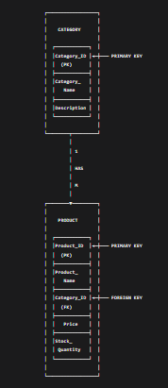
1.2 ER Diagram with Attributes (Crow's Foot Notation)
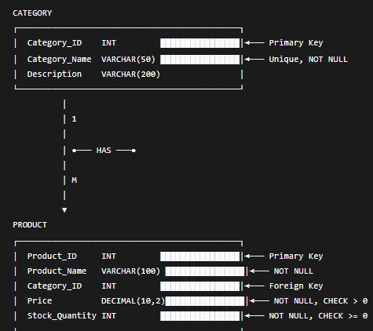
1.3 Detailed ER Diagram with Data Types and Constraints
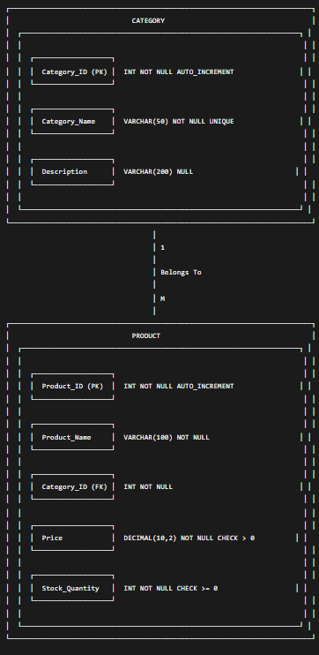│
RELATIONSHIP: Category HAS Product
Type: One-to-Many (1:M)
Cardinality: One Category can have Many Products
Participation: Category (Optional) | Product (Mandatory)

2. Conversion to Relational Schema
2.1 Relational Schema in Standard Notation
text
CATEGORY (Category_ID, Category_Name, Description)
PRIMARY KEY (Category_ID)
UNIQUE (Category_Name)

PRODUCT (Product_ID, Product_Name, Category_ID, Price, Stock_Quantity)
PRIMARY KEY (Product_ID)
FOREIGN KEY (Category_ID) REFERENCES CATEGORY(Category_ID)
CHECK (Price > 0)
CHECK (Stock_Quantity >= 0)
Notation:
- Bold + Underline = Primary Key
- Italic = Foreign Key
- Normal text = Non-key attributes

2.2 Relational Schema with Detailed Specifications
Table 1: CATEGORY
Column Name | Data Type | Constraints | Description
Category_ID | INT | PRIMARY KEY, NOT NULL, AUTO_INCREMENT | Unique category identifier
Category_Name | VARCHAR(50) | NOT NULL, UNIQUE | Name of the category
Description | VARCHAR(200) | NULL | Additional category details
Schema Notation:
text
CATEGORY (
Category_ID: INT [PK, NN, AI],
Category_Name: VARCHAR(50) [NN, UQ],
Description: VARCHAR(200) [NULL]
)

Table 2: PRODUCT
Column Name | Data Type | Constraints | Description
Product_ID | INT | PRIMARY KEY, NOT NULL, AUTO_INCREMENT | Unique product identifier
Product_Name | VARCHAR(100) | NOT NULL | Name of the product
Category_ID | INT | NOT NULL, FOREIGN KEY | References Category.Category_ID
Price | DECIMAL(10,2) | NOT NULL, CHECK (Price > 0) | Product selling price
Stock_Quantity | INT | NOT NULL, CHECK (Stock_Quantity >= 0) | Available stock quantity
Schema Notation:
text
PRODUCT (
Product_ID: INT [PK, NN, AI],
Product_Name: VARCHAR(100) [NN],
Category_ID: INT [NN, FK → CATEGORY.Category_ID],
Price: DECIMAL(10,2) [NN, CK > 0],
Stock_Quantity: INT [NN, CK >= 0]
)

3. Complete Relational Database Schema
3.1 Schema Diagram
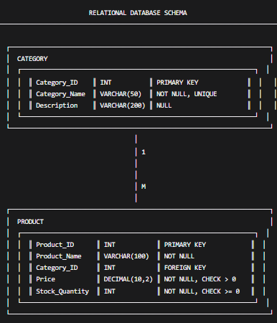
3.2 SQL DDL Implementation
sql
-- Create CATEGORY table
CREATE TABLE Category (
Category_ID INT PRIMARY KEY AUTO_INCREMENT,
Category_Name VARCHAR(50) NOT NULL UNIQUE,
Description VARCHAR(200) NULL
);

-- Create PRODUCT table with foreign key constraint
CREATE TABLE Product (
Product_ID INT PRIMARY KEY AUTO_INCREMENT,
Product_Name VARCHAR(100) NOT NULL,
Category_ID INT NOT NULL,
Price DECIMAL(10,2) NOT NULL CHECK (Price > 0),
Stock_Quantity INT NOT NULL CHECK (Stock_Quantity >= 0),
FOREIGN KEY (Category_ID) REFERENCES Category(Category_ID)
);

4. Relational Mapping Summary
4.1 Mapping Rules Applied
Step | Description | Application
Step 1 | Create a relation for each entity | Category, Product
Step 2 | Add primary keys to each relation | Category_ID, Product_ID
Step 3 | Add foreign keys for relationships | Category_ID in Product
Step 4 | Define data types for each attribute | INT, VARCHAR, DECIMAL
Step 5 | Apply integrity constraints | NOT NULL, UNIQUE, CHECK

4.2 Complete Entity-Attribute Mapping
text
┌────────────────────────────────────────────────────────────────────────────┐
│ ENTITY: CATEGORY │
│ ───────────────── │
│ │
│ Category_ID ──→ INT (Primary Key) │
│ Category_Name ──→ VARCHAR(50) (Unique, Not Null) │
│ Description ──→ VARCHAR(200) (Optional) │
│ │
│ Primary Key: {Category_ID} │
│ Candidate Keys: {Category_ID}, {Category_Name} │
│ │
├────────────────────────────────────────────────────────────────────────────┤
│ ENTITY: PRODUCT │
│ ───────────────── │
│ │
│ Product_ID ──→ INT (Primary Key) │
│ Product_Name ──→ VARCHAR(100) (Not Null) │
│ Category_ID ──→ INT (Foreign Key → Category) │
│ Price ──→ DECIMAL(10,2) (Not Null, > 0) │
│ Stock_Quantity ──→ INT (Not Null, >= 0) │
│ │
│ Primary Key: {Product_ID} │
│ Foreign Key: {Category_ID} references Category.Category_ID │
│ │
├────────────────────────────────────────────────────────────────────────────┤
│ RELATIONSHIP: Category ── HAS ── Product │
│ ────────────────────────────────────────────────────────────── │
│ │
│ Type: One-to-Many (1:M) │
│ Parent: Category (1 side) │
│ Child: Product (M side) │
│ Foreign Key: Category_ID in Product │
│ Participation: Category (partial), Product (total) │
│ Cardinality: One Category → Many Products │
│ │
└────────────────────────────────────────────────────────────────────────────┘

5. Relational Schema Documentation
5.1 Table Definitions
Table Name: CATEGORY
Purpose: Stores product category information
Column | Type | Length | Nullable | Default | Constraints
Category_ID | INT | - | No | AUTO | PRIMARY KEY
Category_Name | VARCHAR | 50 | No | - | UNIQUE
Description | VARCHAR | 200 | Yes | NULL | -
Indexes:
- PRIMARY KEY (Category_ID)
- UNIQUE INDEX (Category_Name)

Table Name: PRODUCT
Purpose: Stores product and inventory information
Column | Type | Length | Nullable | Default | Constraints
Product_ID | INT | - | No | AUTO | PRIMARY KEY
Product_Name | VARCHAR | 100 | No | - | -
Category_ID | INT | - | No | - | FOREIGN KEY
Price | DECIMAL | 10,2 | No | - | CHECK > 0
Stock_Quantity | INT | - | No | - | CHECK >= 0
Indexes:
- PRIMARY KEY (Product_ID)
- FOREIGN KEY (Category_ID) REFERENCES Category(Category_ID)
- INDEX (Category_ID) for join performance

5.2 Relationship Documentation
Relationship Name: Category_Has_Product
Type: One-to-Many (1:M)
Parent Entity: CATEGORY
Child Entity: PRODUCT
text
┌──────────────────────────┬─────────────────────────────────────────────────┐
│ CATEGORY │ PRODUCT │
│ ├── Category_ID (PK) │ ├── Product_ID (PK) │
│ ├── Category_Name │ ├── Product_Name │
│ └── Description │ ├── Category_ID (FK) → Category.Category_ID │
│ │ ├── Price │
│ │ └── Stock_Quantity │
└──────────────────────────┴─────────────────────────────────────────────────┘

6. Data Dictionary
6.1 CATEGORY Table Data Dictionary
Attribute | Description | Format | Example
Category_ID | Unique identifier for category | Integer | 1
Category_Name | Name of the product category | String (max 50 chars) | "Electronics"
Description | Detailed category description | String (max 200 chars) | "Electronic devices and accessories"
6.2 PRODUCT Table Data Dictionary
Attribute | Description | Format | Example
Product_ID | Unique identifier for product | Integer | 101
Product_Name | Name of the product | String (max 100 chars) | "Laptop"
Category_ID | Foreign key to Category | Integer | 1
Price | Product selling price | Decimal (10,2) | 55000.00
Stock_Quantity | Available inventory count | Integer | 20

7. Normalization Analysis
7.1 Normalization Status
Table | Normal Form | Justification
CATEGORY | 3NF | • All attributes depend on primary key (Category_ID)  • No transitive dependencies  • No partial dependencies
PRODUCT | 3NF | • All attributes depend on primary key (Product_ID)  • No transitive dependencies  • No partial dependencies
7.2 Functional Dependencies
CATEGORY Table:
text
Category_ID → Category_Name, Description
Category_Name → Category_ID, Description (since Category_Name is UNIQUE)
PRODUCT Table:
text
Product_ID → Product_Name, Category_ID, Price, Stock_Quantity
Category_ID → Category_Name (through JOIN)

8. SQL Implementation with Sample Data
8.1 Complete DDL Statements
sql
-- Create database
CREATE DATABASE IF NOT EXISTS ProductManagement;
USE ProductManagement;

-- Create CATEGORY table
CREATE TABLE Category (
Category_ID INT PRIMARY KEY AUTO_INCREMENT,
Category_Name VARCHAR(50) NOT NULL UNIQUE,
Description VARCHAR(200)
);

-- Create PRODUCT table
CREATE TABLE Product (
Product_ID INT PRIMARY KEY AUTO_INCREMENT,
Product_Name VARCHAR(100) NOT NULL,
Category_ID INT NOT NULL,
Price DECIMAL(10,2) NOT NULL CHECK (Price > 0),
Stock_Quantity INT NOT NULL CHECK (Stock_Quantity >= 0),
FOREIGN KEY (Category_ID) REFERENCES Category(Category_ID)
);
8.2 Sample Data Insertion
sql
-- Insert Category data
INSERT INTO Category (Category_ID, Category_Name, Description) VALUES
(1, 'Electronics', 'Electronic devices and accessories'),
(2, 'Clothing', 'Men and women clothing products'),
(3, 'Books', 'Educational and general books'),
(4, 'Home Appliances', 'Appliances used at home');

-- Insert Product data
INSERT INTO Product (Product_ID, Product_Name, Category_ID, Price, Stock_Quantity) VALUES
(101, 'Laptop', 1, 55000.00, 20),
(102, 'Smartphone', 1, 25000.00, 35),
(103, 'Headphones', 1, 2500.00, 50),
(104, 'T-Shirt', 2, 800.00, 60),
(105, 'Jeans', 2, 1800.00, 40),
(106, 'Python Programming', 3, 650.00, 30),
(107, 'Database Management Systems', 3, 750.00, 25),
(108, 'Refrigerator', 4, 32000.00, 10),
(109, 'Washing Machine', 4, 28000.00, 15),
(110, 'Smart Watch', 1, 4500.00, 25);

9. Query Examples for Relational Operations
9.1 Simple Queries
sql
-- Display all products with category information
SELECT p.Product_ID, p.Product_Name, c.Category_Name, p.Price, p.Stock_Quantity
FROM Product p
JOIN Category c ON p.Category_ID = c.Category_ID;

-- Count products per category
SELECT c.Category_Name, COUNT(p.Product_ID) AS Product_Count
FROM Category c
LEFT JOIN Product p ON c.Category_ID = p.Category_ID
GROUP BY c.Category_Name;

-- Find most expensive product in each category
SELECT c.Category_Name, MAX(p.Price) AS Highest_Price
FROM Category c
JOIN Product p ON c.Category_ID = p.Category_ID
GROUP BY c.Category_Name;

